**Serving Static Files**

* Static Files are typically located in the web root that is <content-root>/wwwroot) folder.
* In order for static files to be served you must configure the MiddleWare to add static files to the Pipeline.
* The Static file middleware can be configured by adding a dependency

Microsoft.ASPNetCore.StaticFiles Package

* You need to call UseStaticFiles extension method to do this.

Demo 1 : How to Serve Static Files

1. Open Visual Studio 2017
2. Create ne ASP.Net Empty Core Application
3. This will create following Project Structure

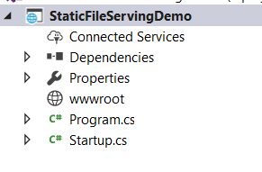

1. Now Add index.html in the Main Folder

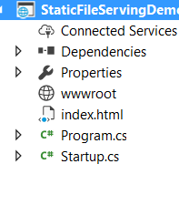

1. Try to access this file . No Output



1. Paste index.html in www root folder

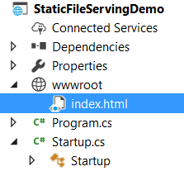

1. Still this file is not accessible
2. To Make it accessible , you need to use add middleware UseStaticFiles and todo this we need add dependency named as Microsoft.ASPNetCore.StaticFiles

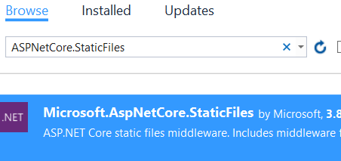

1. Use the middleware in Configure method inside start up class so that Static Files can be served

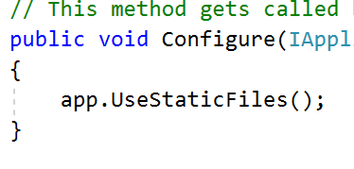

1. Output : Now index.html will be available



1. Index.html is not available at the root . So we need to add UseDefaultFile middleware so that by default index.html file will be given

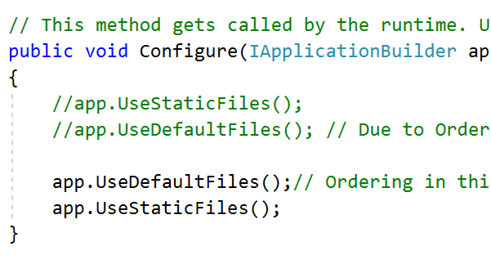

1. Output : Now index.html will be available at root level



1. ASP.Net MVC always checks for index.html or .htm or default.htm or .html file . You might want to change the default behaviour and may be you want to send some other file. Add test.html

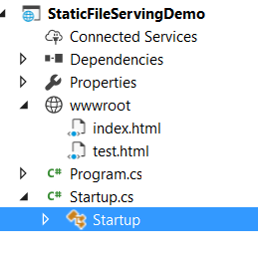

1. Now we want to send test.html as our default file.

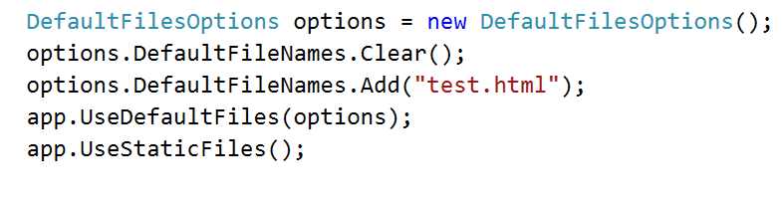

1. See the output



Static File Authorization

* Static file module provides no authorization checks, Any files served by it, including those under wwwroot are publicly available.

You can apply authorization to it using 2 ways

1. Keep it outside wwwroot folder
2. Serve them from controller action

**Enabling Directory browsing**.

* Directory browsing allows you to see list of directories and files within specified directory
* Its disabled by default for security reasons
* To enable it use UseDirectoryBrowser extension method

Demo : How to allows browsing in list of directory

1. Add UseDirectoryBrowser method in configure

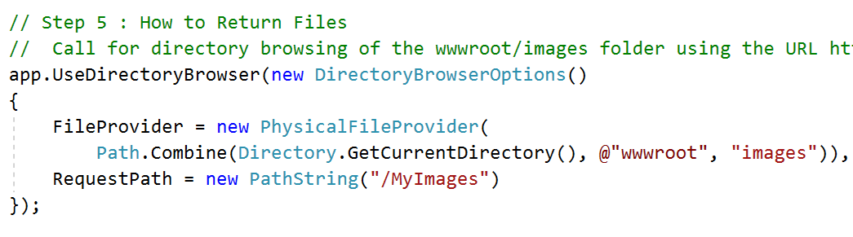

1. Enable directory browseing in ConfigureServices

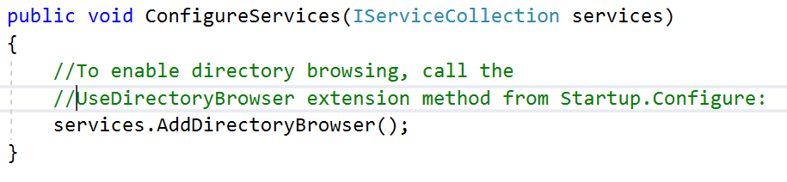

1. Output

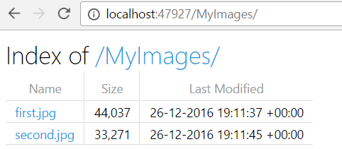

Use File Server

* It combines the functionality of UseStaticFiles,UseDefaultFiles and UseDirectoryBrowser
* It enables static files and default files to be served but doesn’t allows directory browsing.

Demo 4: add File server middleware

1. Add app.useFileServer in configure method

This will allow access to each and every files but wont allow directory browsing

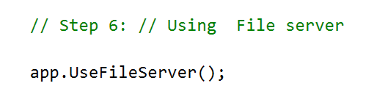

1. In following URL first.jpg is allowed to access but images folder is not browsable

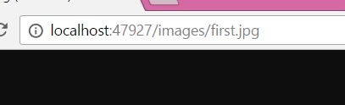

1. Go to images URL



1. We can enable fileserver including directory browsing

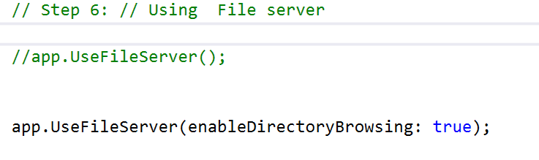

1. Now directory browsing is allowed

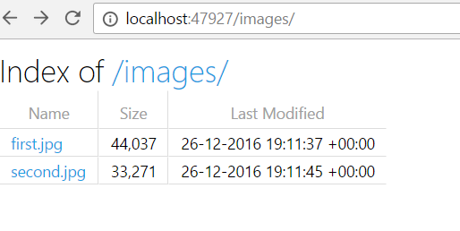

If you wish to serve files that exist outside the webroot , you instantiate and configure FileServerOptions object that you pass to UseFileServer.

1. Add a new StaticFiles folder and add some dummy files into it

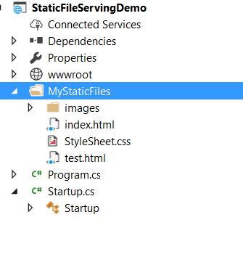

1. Change the configure method to serve from this folder

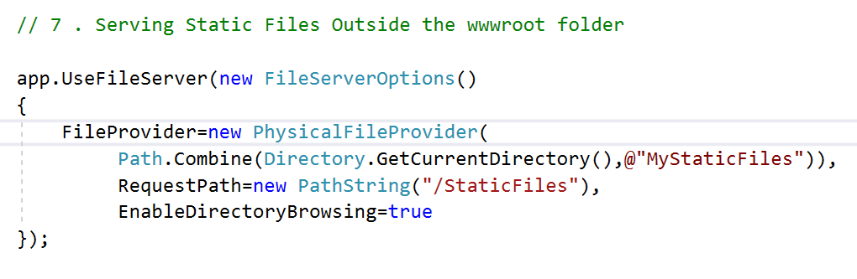

1. Check the output

